Patient Lookup System
Github link of source code: https://github.com/romanaengg/patientlookupapp
Test Accounts
The application includes two demonstration accounts.
Standard User
Username: patientuser
Password: User123!
Role: USER
This account can view patient information but cannot modify patient records.
Administrator
Username: patientadmin
Password: Admin123!
Role: ADMIN
This account can view, create, update, and delete patient records.

Design and Architecture Document
1. System Overview
The Patient Lookup System is a web-based application designed to allow authorized users to view and manage patient information through a secure web interface.
The system consists of two main components:
- Frontend: React application along with Bootstrap CSS providing the user interface.
- Backend: Java Spring Boot REST API responsible for business logic, authentication/authorization, database access, and CRUD operations.
Patient information is stored in a MySQL relational database.
The system supports role-based access control:
- USER – Can view patient records.
- ADMIN – Can view, create, update, and delete patient records.
The application uses HTTP Basic Authentication. Authentication is handled by Spring Security, while authorization is enforced through role-based security annotations on the API endpoints.

2. Purpose and Functionality
2.1 Purpose
The purpose of the Patient Lookup System is to provide a simple and secure interface for managing patient records.
The application demonstrates:
- RESTful API development
- Frontend and backend integration
- Relational database integration
- Authentication and authorization
- Role-based access control
- CRUD operations
- Form-based data entry
- Patient record searching and viewing

2.2 System Functionality
The application provides the following functionality.
Patient Listing
Authorized users can view a list of all patients stored in the database.
The list displays relevant patient information and allows the user to select an individual patient.
Patient Search
Users can search patients with firstname.
The search list displays all the patients with matching firstname in the search box.
Patient Details
Users can select a patient and view their complete record.
Patient Creation
Administrators can create a new patient record using a form.
The application sends patient information to the backend using an HTTP POST request.
Patient Update
Administrators can select an existing patient and edit their information.
The application sends the updated information to the backend using an HTTP PUT request.
Patient Deletion
Administrators can delete an existing patient.
The application sends an HTTP DELETE request to the backend.
Authentication
Users must authenticate before accessing patient information.
The system currently provides two test accounts which are given at the start of this document.
These accounts are stored in memory using Spring Security for demonstration purposes.
Authorization
The backend enforces access control independently of the frontend.
Operation | USER | ADMIN
View all patients | Yes | Yes
View patient details | Yes | Yes
Create patient | No | Yes
Update patient | No | Yes
Delete patient | No | Yes
This ensures that hiding buttons in the React application is not the only security mechanism. The backend also prevents unauthorized requests.

3. Architecture and Technology
3.1 Architecture
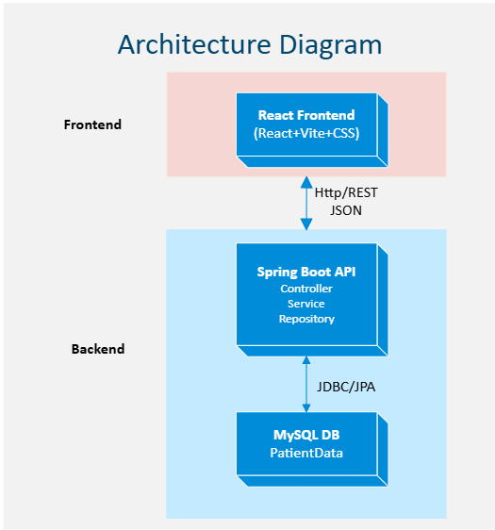
The application uses a three-tier architecture consisting of:

This architecture separates presentation, business logic, and data access.

Presentation Layer
The React frontend is responsible for:
- Displaying patient information
- Login interface
- Patient forms
- Navigation
- Displaying errors and status messages
- Sending HTTP requests to the API
- Showing functionality based on the user's role
Application/Business Layer
The Spring Boot backend contains:
- REST controllers
- Service classes
- Authentication and authorization
- Business logic
- Request processing
The service layer separates business logic from the REST controllers.
Data Access Layer
Spring Data JPA repositories are responsible for communicating with MySQL.
The repository provides operations such as:
- Find all patients
- Find a patient by ID or first name
- Save a patient
- Delete a patient
Database Layer
MySQL stores persistent patient information.

4. Technology Selection
4.1 Backend – Java Spring Boot
Spring Boot was selected for the backend because it provides a well-established framework for developing RESTful Java applications.
Benefits include:
- REST API support
- Dependency injection
- Spring Data JPA integration
- Spring Security
- Database integration
- Clear separation of application layers
The backend uses Java 21.
4.2 Frontend – React
React was selected as the frontend framework because it is a modern JavaScript framework/library commonly used for interactive web applications.
React provides:
- Component-based development
- State management through React hooks
- Dynamic forms
- Conditional rendering
- Easy integration with REST APIs
The project uses Vite as the React development/build tool.
4.3 CSS – Bootstrap
Bootstrap is used to provide responsive styling and common UI components.
It provides:
- Responsive layouts
- Forms
- Buttons
- Tables
- Navigation elements
- Consistent styling
The application also uses Lucide React for interface icons.

4.4 Database – MySQL
MySQL was selected as the relational database because it is open source, reliable, and well suited to structured application data.
The application communicates with MySQL through Spring Data JPA/Hibernate.

4.5 Security – Spring Security
Spring Security is used to provide:
- Authentication
- HTTP Basic Authentication
- Role-based authorization
- Protection of REST endpoints
The backend uses @PreAuthorize annotations to restrict operations based on user roles.
For example:
@PreAuthorize("hasRole('ADMIN')")
restricts delete/create/edit operation to administrators.

5. Database Schema
The primary database table is patients.
Patients Table
Column | Data Type | Description
patient_id | BIGINT | Primary key and unique patient identifier
first_name | VARCHAR(100) | Patient first name
last_name | VARCHAR(100) | Patient last name
date_of_birth | DATE | Patient date of birth
gender | VARCHAR(50) | Patient gender
city | VARCHAR(100) | Patient city
created_at | TIMESTAMP | Record creation timestamp
updated_at | TIMESTAMP | Last modification timestamp
The primary key is:
patient_id
The patient ID is automatically generated when a new patient is created.
The created_at and updated_at fields are populated by the application when records are created or updated.
Database Relationship
The current system contains one primary entity:
PATIENT-
patient_id ── Unique patient record
There are currently no additional relationships.

6. API Endpoints
The base API URL is:
http://localhost:8080/api/patients
All patient endpoints require authentication.
6.1 Get All Patients
Request
GET /api/patients
Authorization
USER or ADMIN
Description
Returns all patient records from the database.
Example Response
[
{
"patientId": 1,
"firstName": "John",
"lastName": "Smith",
"dateOfBirth": "1990-01-15",
"gender": "Male",
"city": "Regina"
"createdAt": "2026-09-20T18:47:15.880Z",
"updatedAt": "2026-09-20T18:47:15.880Z"
}
]

6.2 Get Patient by ID
Request
GET /api/patients/{patientId}
Authorization
USER or ADMIN
Description
Returns a specific patient using their unique patient ID.
Example
GET /api/patients/1

6.3 Create Patient
Request
POST /api/patients
Authorization
ADMIN only
Description
Creates a new patient record.
Example Request Body
{
"firstName": "John",
"lastName": "Smith",
"dateOfBirth": "1990-01-15",
"gender": "Male",
"city": "Regina"
}
The patient ID is generated by the database/application.
createdAt and updatedAt are generated by the application based on local time .If it is a new record the value of both will be same.

6.4 Update Patient
Request
PUT /api/patients/{patientId}
Authorization
ADMIN only
Description
Updates an existing patient record.
Example
PUT /api/patients/1
Example Request Body
{
"firstName": "John",
"lastName": "Smith",
"dateOfBirth": "1990-01-15",
"gender": "Male",
"city": "Saskatoon"
}
The backend retrieves the existing patient using the ID and updates the existing record rather than creating a new patient.
In addition, application also updates the updatedAt with the local time. Only updatedAt is changed since createdAt needs to show the time stamp of original account creation.

6.5 Delete Patient
Request
DELETE /api/patients/{patientId}
Authorization
ADMIN only
Description
Deletes the specified patient record from the database.
Example
DELETE /api/patients/1

7. API Security
All patient endpoints are protected by Spring Security.
The security rules are conceptual:
/api/patients/**
GET → USER or ADMIN
POST → ADMIN
PUT → ADMIN
DELETE → ADMIN
The backend uses HTTP Basic Authentication.
Credentials are transmitted through the HTTP Authorization header.
The passwords for the demonstration accounts are encoded using BCrypt by Spring Security.
The frontend also uses the authenticated user's role to determine which operations should be displayed. However, authorization is ultimately enforced by the backend.

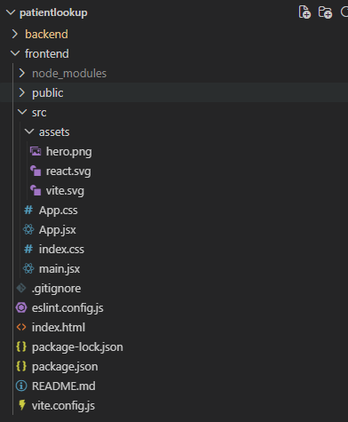
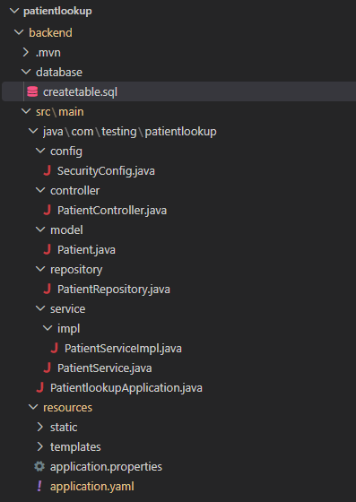
8. Project Structure The project is organized into separate backend and frontend applications.

9. System Setup
Prerequisites
The following software is required if setting up in an IDE:
- Java JDK 21
- MySQL
- Node.js and npm
- Visual Studio Code or another Java/JavaScript IDE
- Git (if obtaining the project from source control)

10. Database Setup
Install and start MySQL.
Create the database used by the application.
For example:
CREATE DATABASE patient_db;
Create the patients table using the project's database schema.
CREATE TABLE patients (
patient_id BIGINT AUTO_INCREMENT PRIMARY KEY,
first_name VARCHAR(100) NOT NULL,
last_name VARCHAR(100) NOT NULL,
date_of_birth DATE NOT NULL,
gender VARCHAR(50),
city VARCHAR(100),
created_at TIMESTAMP NOT NULL DEFAULT CURRENT_TIMESTAMP,
updated_at TIMESTAMP NOT NULL DEFAULT CURRENT_TIMESTAMP ON UPDATE CURRENT_TIMESTAMP
);
The MySQL connection settings must be configured in the Spring Boot application's configuration file.
Current file:
spring:
datasource:
url: jdbc:mysql://localhost:3306/patient_db?useSSL=false
username: root
password: *********
driver-class-name: com.mysql.cj.jdbc.Driver
jpa:
hibernate:
ddl-auto: update

The database username and password should be replaced with the local MySQL credentials.

11. Running the Backend
Open a terminal in the backend directory:
cd backend
Run the Spring Boot application using Maven:
.\mvn spring-boot:run
Alternatively, the application can be run directly from the IDE using the Spring Boot main application class.
The backend will normally start on:
http://localhost:8080
The patient API is available at:
http://localhost:8080/api/patients

12. Running the Frontend
Open a second terminal in the frontend directory:
cd frontend
Install the required npm packages if not installed
npm install
Start the Vite development server:
npm run dev
The frontend will normally be available at:
http://localhost:5173
Open that address in a web browser.

13. OpenAPI/Swagger:
OpenAPI configuration is added in the application, and the API endpoint definitions and schemas can be viewed via Swagger UI. The link for swagger is http://localhost:8080/swagger-ui/index.html

Summary
The Patient Lookup System demonstrates a complete full-stack application using React, Spring Boot, Spring Security, Spring Data JPA, and MySQL.
The architecture separates the frontend, REST API, business/service layer, data-access layer, and database. This separation makes the application easier to maintain and provides a clear structure for implementing authentication, authorization, and CRUD functionality.
The REST API provides the required patient operations through standard HTTP methods, while Spring Security ensures that administrative operations are restricted to authorized users.

